Pascal’s Triangle Worksheet
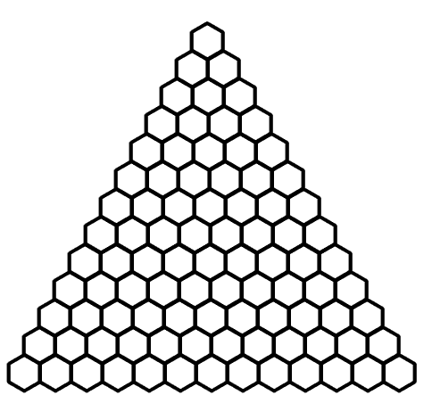
Complete Pascal’s Triangle and use it to determine the pattern for the following sequences. Divide the numbers in each of the hexagons by 5, assign each remainder a color, and shade each hexagon according to the color. Cut out the triangle and with five other people, form a hexagon and mount it on a piece of heavy paper.
Remainder Color
0

1

2

3

4

